**GARAGE GO**

Group 4: Khac Minh Dai Vo, Jerrik Johnson, Colton Goetjen, Travis Xu

*San Jose State University*

Charles W.David College of Engineering

*TECH 190-B: Section 01 - Senior Project II*

*Professor: Nik Tehrani*

*May 14th, 2024*

# **Abstract**

With an idea of a house security solution, our group came up with an idea for a project that aims to create a user-friendly garage security system. After much research, we came up with the Garage Go kit including two products: Smart-Press and Smart Power Toggle which address the issues with traditional key fobs and simplify installation. It includes a mobile app that is easy to control and monitor and our goal is to enhance garage security and provide customers with a piece of mind through our dual locking system. Tasks such as management, manufacturing, coding, app development, and testing are part of our objectives to complete the products.

**Acknowledgments**

Group 4 would like to express our immense appreciation to Dr. Nik Tehrani for his unwavering patience, kindness, care, and consistent support throughout the past two semesters. Dr. Tehrani not only regards us as his students but also as his own sons and daughters, always going above and beyond to ensure our well-being, health, and success in the class. Despite facing numerous challenges from the outset, Group 4 successfully navigated through them with Dr. Tehrani's guidance and assistance, completing every assignment leading up to the final presentation. We were fortunate to receive second place from the judges, a testament to Dr. Tehrani's exceptional teaching and mentorship. He is truly a remarkable professor and a compassionate individual.

**Table of Contents**

**Abstract & Acknowledgement 2**

**Introduction 4**

**Methodology 5**

**Results** **13**

**Conclusion 13**

**References 14**

**Executive Summary**

Our project's main goal was to provide an effective garage security system that emphasizes user-friendliness, cross-platform compatibility, and additional safety features. We determined that a system that strengthens garage security removes the need for traditional key fobs, and streamlines installation procedures was necessary after doing extensive study and analysis. In answer to this difficulty, we developed Garage Go, a complete kit that can be installed and managed by homeowners using a specific mobile application.

We want to create a product where it can help to enhance access control to the garage and avoid the use of the fob because it is one of the main factors for signal-grabbing criminals to gain access and attack our home. The dual locking mechanism, which adds an extra degree of security for homeowners' possessions, is essential to its success. The mobile app control function makes remote garage door monitoring and management incredibly convenient.

**Introduction**

***Mission Statement***

“ Enhancing Garage Safety through Dual Locking System”. Our group mission is to provide homeowners peace of mind and trust in their garage security, which goes beyond simple functioning. Garage Go offers a complete security solution that meets a variety of client demands by combining innovation and practicality in a user-friendly solution. This empowers homeowners to take charge of their garage security with confidence, knowing that their system is dependable and effective. The kit will include 2 products: Smart-Press and Smart-Power Toggle, which can be controlled through the Blynk app and works with WiFi settings.

**Methodology**

***Background and Problems***

The main problem we look to fix has everything to do with security. With that, we chose to base our security on a home's garage door. A garage door has several vulnerabilities from physical attacks to code grabbing. These doors are poorly installed and can easily be infiltrated by an intruder. It’s been shown that roughly 10% of homes burglarized are accessed through the garage and looking at the statistics you can find that over 200,000 attacks happen through the garage yearly. This shows that there’s a big market but also that there's a big problem with garage security. We aim to mitigate these attacks and slow the attackers down with a dual-locking garage door system that can change the whole technique these intruders once knew as easy and make it almost impossible.

***Competitors***

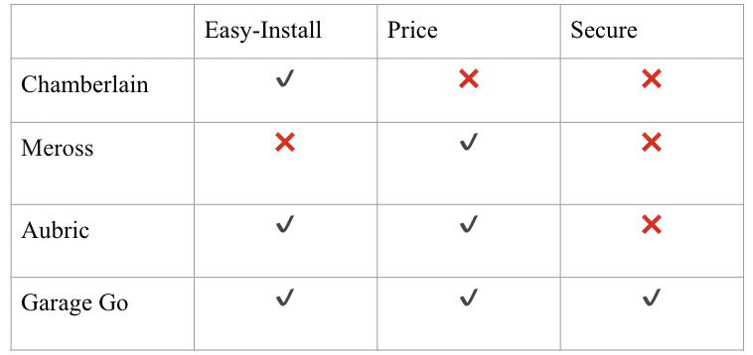

**Table 1.** Competitor Comparison

Garage Go would have plenty of competitors in its market but not many of them stand up to the same excellence as Garage Go. Many of these competitors are just extending access to the garage using an app without thinking about other variables, such as installation, price, or most importantly security. Our product specializes in all three. We are creating a product as a kit to provide an easy setup for security and is very affordable. Our competitors above display all of those characteristics just mentioned. Chamberlin acts as a garage motor company and implements a sort of app-based access but does not offer security, a decent market price, and nowhere close to an easy installation. The other two competitors, Aubric and Meross, are very similar by offering a very affordable product but they don't offer any security to your garage door.

***Primary Market***

**Table 2.** Share of Housing Units with a Garage

The primary market was focused on the United States. As you can see in the above figure, over 65% of houses in the United States have a garage door. There are approximately 144 million homes in the U.S. That means that there are over 93 million homes out there that may be available to our market.

***Work Activities***

As General Task Management & Team Lead, Colton Goetljn oversees the coordination of weekly meetings, ensures deadlines are met, and facilitates communication among team members to track progress. In Manufacturing, Jerrik Johnson handles purchasing parts, 3D printing, and component assembly while liaising with Coding & Testing to align with manufacturing expectations. In the Coding & Testing division, Khac Minh Dai Vo writes C++ code, conducts tests on ESP8266 boards, and takes meeting notes, ensuring alignment with Manufacturing's coding requirements and work on Application development, researching and testing various apps to integrate both products into a single application, including testing Blynk functionality.

***Timeline***

**Table 3.** Table of Schedule for First Semester

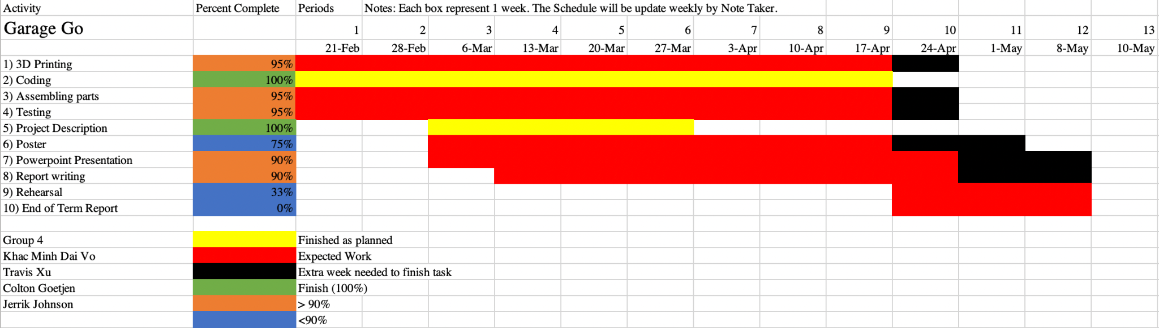

#### **Table 4.** Gantt Chart of Second Semester

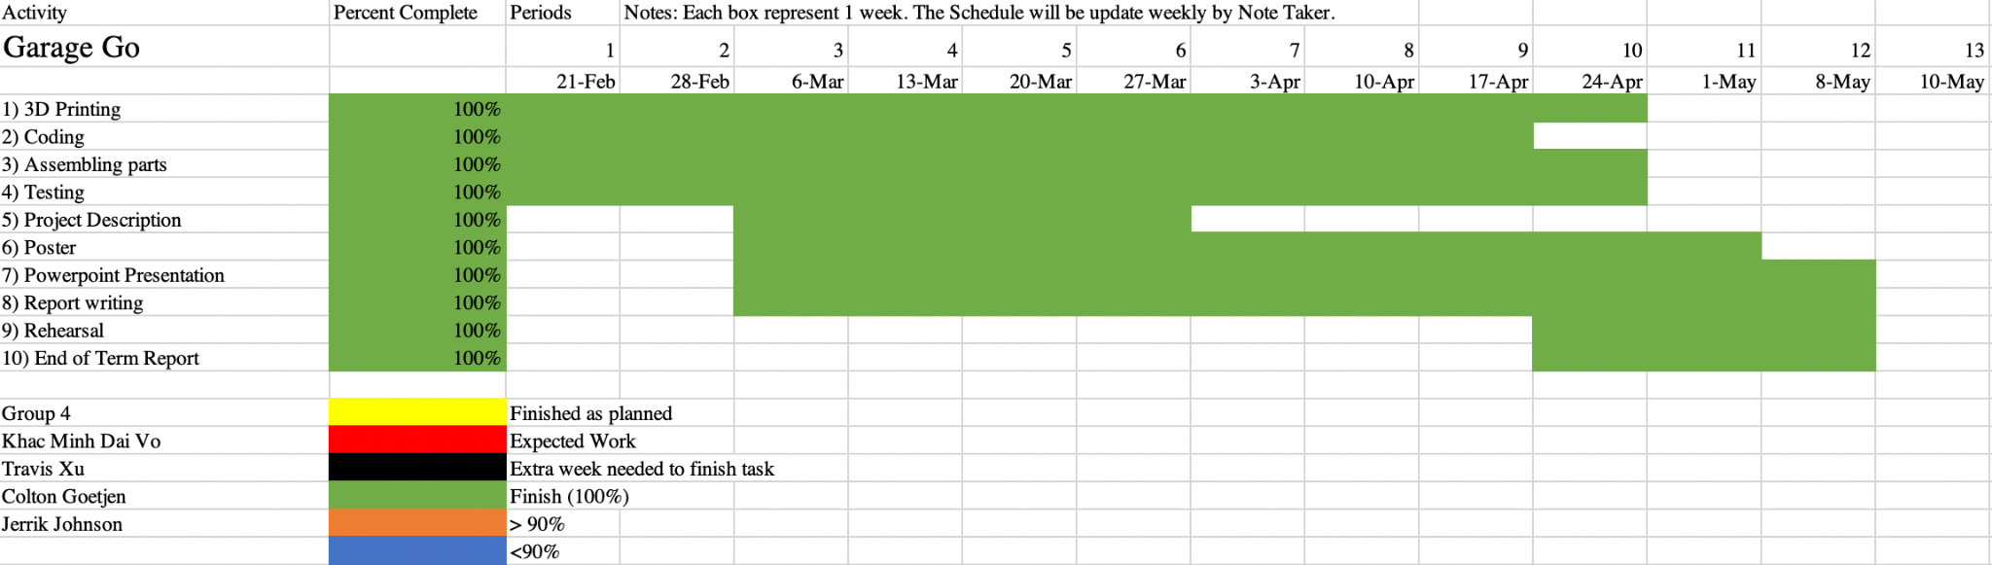

#### **Table 5.** Gantt Chart of Completed Second Semester

There are a total of 10 tasks for the team that need to be completed throughout the second semester. We created a Gantt chart to help us track our progress each week and identify tasks that may require additional time for completion. By the time of the final presentation, all tasks were completed and ready, indicated by their green coloring, signifying a 100% completion rate.

## ***Hardware Components***

## ESP8266 NodeMCU: Acts as the brain of the whole system where it provides commands and controls the kit. It also takes the input from Arduino IDE and sends the output to the kit.

## 5V Relay: Used to control the electricity flows through the circuit.

## LCD Display: Shows the on/off status of the Smart-Power Toggle and status to turn on the Smart-Press.

* Servo: Used for the Smart-press.
* Cables: Connected the components all together.

## ***Software***

* Arduino IDE: This software programmed the Arduino Uno through the ESP8266 board. The code includes libraries that help to work with WiFi, connect with the Blynk app, make sure the servo for the smart press works, and the rest just for the wire and ensure all the functionality works as expected.

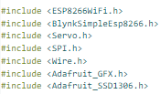

**Figure 1.** Image of libraries for Arduino IDE.

* Formlabs: This software is used to print the 3D models.
* SolidWorks: This software is used to design the 3D models and components for the kit.
* Blynk: Application software that is used to control the kit.

## ***3D Printing Process***

* Design: The kit components were designed using SolidWorks, ensuring precision and compatibility with other hardware components.
* Printing: The prepared models were printed using Formlabs with high accuracy and quality.
* It took a total of 23 hours to print everything.

## 

## 

## 

## 

## ***Bill of Materials***

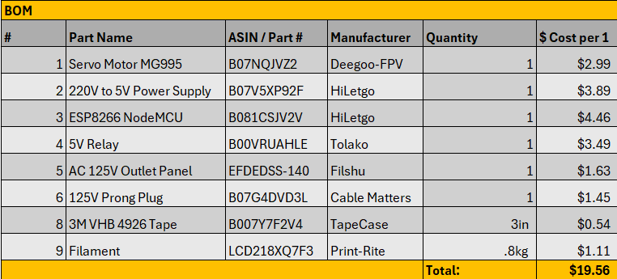

#### **Table 6.** Bills of Materials

***Experimentation***

The experimentation primarily involved coding and application development for the microcontroller ESP8266. Initially, our group's plan was to create two separate products using different boards: ESP8266 for the Smart-Power Toggle and ESP32 for the Smart-Press, both controllable via WiFi. We wrote distinct codes for each and tested them using Arduino IDE. Subsequently, we conducted extensive research and testing to merge these products into a single application. However, despite multiple attempts, the main challenge was integrating them successfully. Thus, we refocused on the ESP8266, delving deeper into its specifications. We discovered that besides its primary functionality, it offers additional layers of functionality without overwriting the main one. Consequently, we opted to eliminate the ESP32 board and integrate the Smart-Press with the ESP8266. After testing, we realized that this approach allowed us to consolidate both products into one, requiring only a combined code in Arduino IDE with the addition of some libraries to ensure smooth operation.

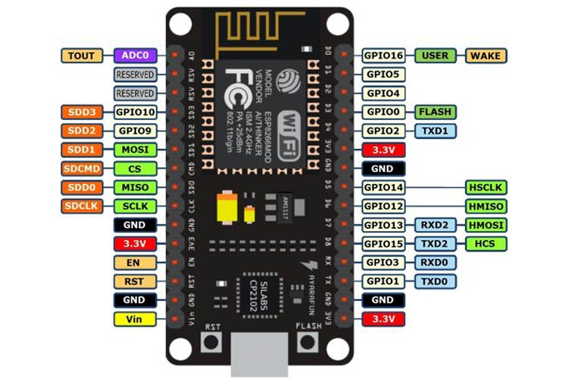

**Figure 2.** ESP8266 Specifications table.

**Results**

This project and product ended with a great amount of success. The app was able to connect to the device and activate the button press to make the garage motor turn on and thereafter press the garage door opener button. This turned out to be a large yet niche idea that works great with the growing world's needs today. After all, IoT is a growing concept and this could fit right into many home systems like Alexa.

**Conclusions & Recommended Future Work**

Overall, our team strives to make homes a safe place by creating a stronger security system through the once-weakest part of the house infrastructure. Through our dual-locking system, we can mitigate almost 98% of attacks and give peace of mind to our customers. In the future, our customers can look forward to a more sleek and modern design, the implementation of an all-inclusive app meaning no more button press installation, and even a wider variety of uses besides just the garage door.

**Appendix: Codes.**

**Figure 3.** Arduino Code

